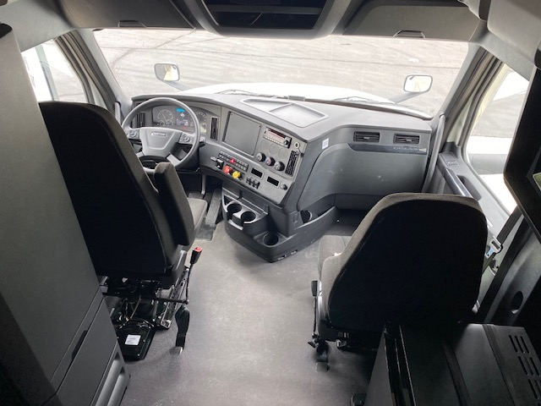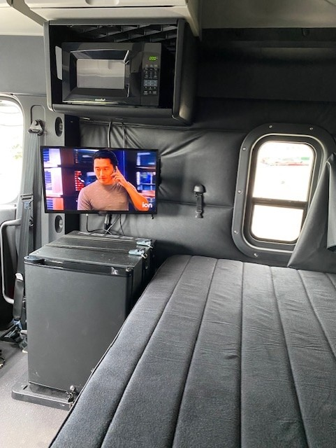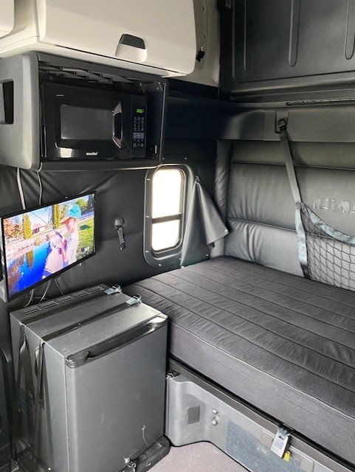
Four Star Greenhouse Equipment
Acquired new 2022 Freightliner Cascadia Sleeper Tractors and Vanguard Trailers
(well-maintained since purchase)
[Grab your reader’s attention with a great quote from the document or use this space to emphasize a key point. To place this text box anywhere on the page, just drag it.]

